MOSFET HW 2 (16 points)
(jas, MOSFET HW 2.docx, 11/25/2025)

Clearly indicate answers and include units for numeric answers, using 3 or 4 significant figures. Show at least the major steps of your work so that if necessary partial credit can be awarded.

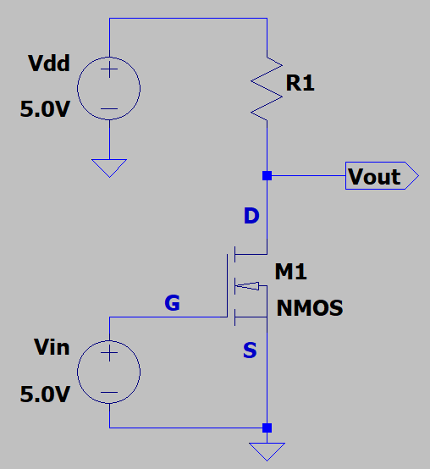
- The data sheet for the n-channel MOSFET in the adjacent circuit provides the following values: V_{T} = 2.0 V, with I_{D} = 0.5 A for V_{GS} = 5.0 V and V_{DS} = 10 V. (8 points total.)

- Using Sah’s equations and the data sheet values, determine β_{n} for the MOSFET. (3 points.)

Region of operation?
$$V_{GS}-V_{T}=3.0V$$
$$5.0V≥3.0V→Transistor Saturation$$
$$I_{D}=\frac{β_{n}}{2}{\left(V_{GS}-V_{T}\right)}^{2}$$
$$β_{n}=\frac{2I_{D}}{{\left(V_{GS}-V_{T}\right)}^{2}}=\frac{2\left(0.5A\right)}{{\left(5.0V-2.0V\right)}^{2}}=0.111\frac{A}{V^{2}}$$
$$β_{n}=0.111\frac{A}{V^{2}}$$

- Using Sah’s equations and your previously calculated β_{n} value, determine the drain current I_{D} for the MOSFET in the above circuit, including units, given that V_{out} = 0.2 V. (3 points.
$$I_{D}=\left(0.111\frac{A}{V^{2}}\right)\left[\left(5.0V-2.0V\right)\left(0.2V\right)-\frac{{\left(0.2V\right)}^{2}}{2}\right]=0.0644 A$$
$$I_{D}=0.0644 A$$

- Using your previously calculated I_{D} value for V_{out} = 0.2 V in the above MOSFET circuit, determine $R_{DS(ON)}=\frac{V_{DS}}{I_{D}}$, including units. (Hint: R_{DS(ON)} should be in the range of 2.5 to 3.5 Ω.) (2 points.)
$$R_{DS(ON)}=\frac{0.2V}{0.0644A}=3.103Ω; R_{DS(ON)}=3.103Ω$$
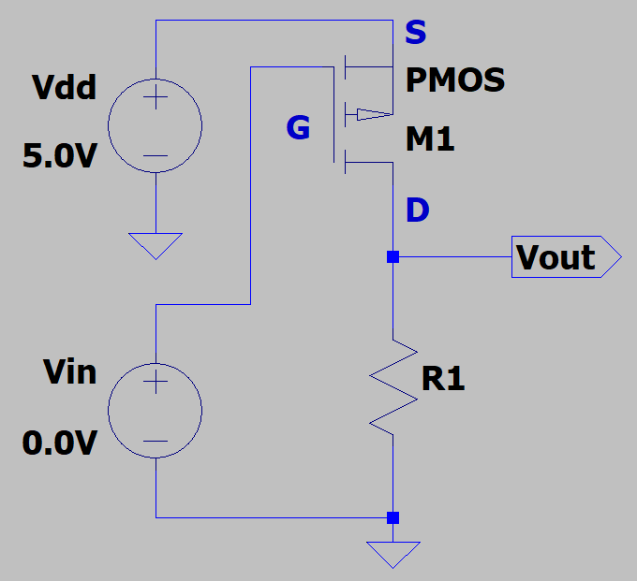
- The data sheet for the p-channel MOSFET in the adjacent circuit provides the following values: V_{T} = -2.0 V, with I_{D} = -0.24 A for V_{GS} = -5.0 V and V_{DS} = -10 V, which is the same as V_{SG} = 5.0 V and V_{SD} = 10 V. (8 points total.)

- Using Sah’s equations and the data sheet values, determine β_{p} for the MOSFET. (3 points.)

Region of operation?
$$V_{SD}≥V_{SG}-\left|V_{T}\right|→Transistor Saturation$$
$$I_{D}=\frac{β_{p}}{2}{\left(V_{SG}-\left|V_{T}\right|\right)}^{2}$$
$$β_{p}=-\frac{2I_{D}}{{\left(V_{SG}-\left|V_{T}\right|\right)}^{2}}=-\frac{2\left(-0.24A\right)}{{\left(5.0V-\left|-2.4V\right|\right)}^{2}}=0.0533\frac{A}{V^{2}}$$
$$β_{p}=0.0533\frac{A}{V^{2}}$$

- Using Sah’s equations and your previously calculated β_{p} value, determine the drain current I_{D} for the MOSFET in the above circuit, including units, given that V_{out} = 4.8 V. (3 points.)

Region of operation?
$$V_{dd}-V_{out}=V_{SD}→5.0V-4.8V=0.2V$$
$$V_{SG}≥\left|V_{T}\right|;0<V_{SD}<V_{SG}-\left|V_{T}\right|→Ohmic$$
$$I_{D}={-β}_{p}\left[\left(V_{SG}-\left|V_{T}\right|\right)V_{SD}-\frac{V_{SD}^{2}}{2}\right]=-0.0533\frac{A}{V^{2}}\left[\left(5.0V-\left|-2.0V\right|\right)0.2V-\frac{{\left(0.2\right)}^{2}}{2}\right]$$
$I_{D}=-0.0309$A

- Using your previously calculated I_{D} value for V_{out} = 4.8 V in the above MOSFET circuit, determine $R_{DS(ON)}=\frac{V_{SD}}{{|I}_{D}|},$ including units. (Hint: R_{DS(ON)} should be in the range of 6.3 to 6.6 Ω.) (2 points.)
$$R_{DS\left(ON\right)}=\frac{V_{SD}}{{|I}_{D}|}=\frac{0.2V}{\left|-0.0309A\right|}=6.4655 Ω$$
$$R_{DS(ON)}=6.4655 Ω$$

